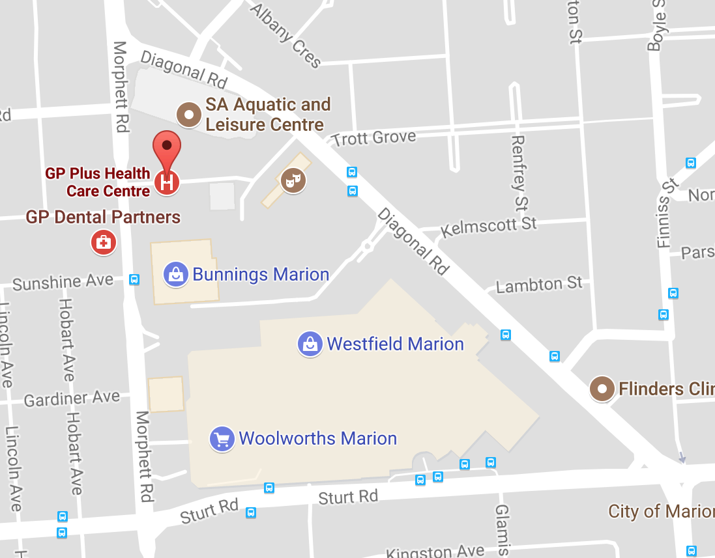
Marion GP Plus Health Care Centre
10 Milham St, Oaklands Park SA 5046

Transport:
- Bus
- Train
- Free carparking available (entry via Milham St). Park on level 3 and above

On the day:
- Present to Ground Floor Reception. Swipe card will be issued for SADS Clinic access
- Session times (including site induction)
  - AM: 8:35 – 12:00
  - PM: 12:35 – 4:00
- First student patients arrive at 9am for the AM session and 1pm for the PM session
- If you have attended this clinic before and have received site induction, arrive 15 minutes before first patients arrive
- Return swipe card and sign out at end of day

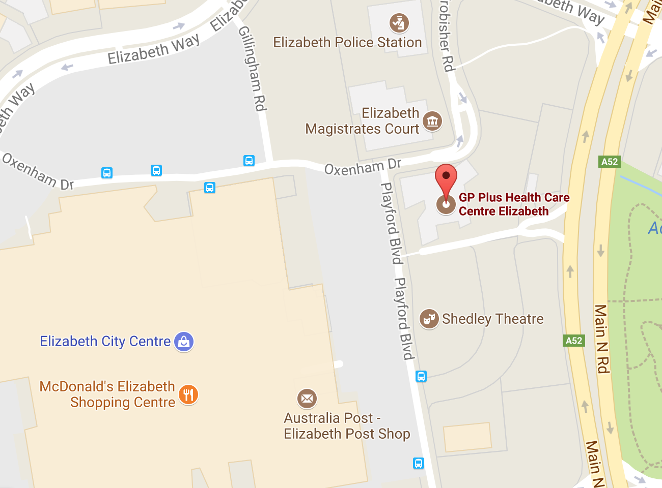
Elizabeth GP Plus Health Care Centre
Level 1, 16 Playford Boulevard, Elizabeth SA 5112

Transport
- Free carparking adjacent to Elizabeth HCC - entry off Main North Road by the Elizabeth City Centre tall grey marker pole or Frobisher Road (off Elizabeth Way)
- Elizabeth Railway Station to Elizabeth GP+ HCC via Oxenham Way – Approx 9 Minutes
- Approx 45 minutes from North Terrace including walk from Elizabeth Railway Station to Elizabeth GP+HCC
- Bus stop 64B Playford Boulevard - Approx 3 minutes C1 Bus from Stop 12 (RAH) to Bus Stop 64B – Approx 50 minutes (NOTE: C1 bus timetable has been affected by OBahn works and local roadworks in Playford Boulevard- please confirm bus schedules)

On the day:
- Present to SADS Clinic Reception, Level 1. Swipe card will be issued for SADS Clinic access
- Session times (including site induction)
  - AM: 8:35 – 12:00
  - PM: 12:35 – 4:00
- Site induction will be conducted
- First student patients arrive at 9am for the AM session and 1pm for the PM session
- If you have attended this clinic before and have received site induction, arrive 15 minutes before first patients arrive
- Return swipe card and sign out at end of day

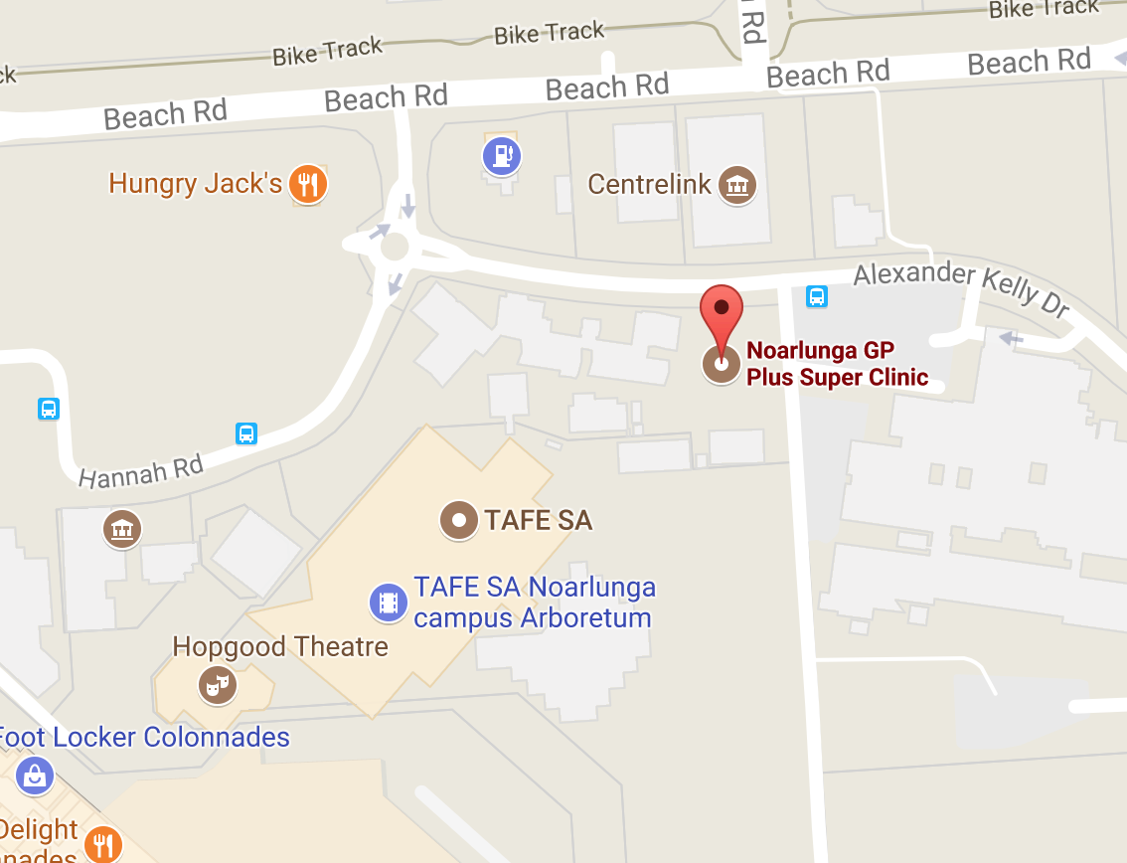
Noarlunga GP Plus Super Clinic
Alexander Kelly Dr, Noarlunga Centre SA 5168

Transport:
- Bus
- Train
- Free carparking available at nearby Hungry Jacks

On the day:
- Present to Noarlunga Hospital (adjacent to the clinic). Swipe card will be issued for SADS Clinic access
- Session times (including site induction)
  - AM: 8:35 – 12:00
  - PM: 12:35 – 4:00
- Site induction will be conducted
- First student patients arrive at 9am for the AM session and 1pm for the PM session
- If you have attended this clinic before and have an access card, arrive 15 minutes before first patients arrive
- Return swipe card and sign out at end of day

